Assignment
Data Structures & Algorithms

(UEE-410)
Name: Vidhish Sangwan Roll No: 1024040087

Class Group: - 3D13

Submitted to: Dr. Mukesh Dalal



DEPARTMENT OF

ELECTRICAL & INSTRUMENTATION ENGINEERING

THAPAR INSTITUTE OF ENGINEERING AND TECHNOLOGY, (A DEEMED TO BE UNIVERSITY), PATIALA, PUNJAB
INDIA

INDEX

SR.No. | Topic
1. | Programs in ‘C’ language
2. | Arrays and Pointers
3. | String Processing operations
4. | Linked-list
5. | Stacks and its Applications
6. | Queues
7. | Sorting algorithms
Programs in C

Q1.Write a program in C to convert miles into kilometers (Km).
Hint: 1 Mile=1.609 Km. [Use macros, relevant name and types for variables].

Ans.1
#include <stdio.h>

#define KM_IN_ONE_MILE 1.609

int main()
{
double distanceMiles;
double distanceKm;

printf("Enter distance in miles: ");
scanf("%lf", &distanceMiles);

distanceKm = distanceMiles * KM_IN_ONE_MILE;

printf("Distance in kilometers: %.2f\n", distanceKm);

return 0;

}

OUTPUT:

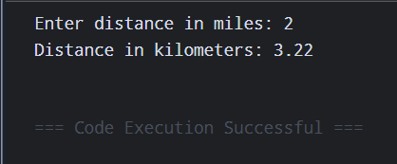

Q2. Write a program to find the number of positive, negative and zeros in a sequence of inputs (numbers) entered as data.

Ans.2 #include <stdio.h>

int main()
{
int totalNumbers;
int currentNumber;
int positiveCount = 0;
int negativeCount = 0;
int zeroCount = 0;

printf("How many numbers will you enter? ");
scanf("%d", &totalNumbers);

printf("Enter the numbers:\n");

for (int index = 0; index < totalNumbers; index++)
{
scanf("%d", &currentNumber);

if (currentNumber > 0)
positiveCount++;
else if (currentNumber < 0)
negativeCount++;
else
zeroCount++;
}

printf("Positive numbers: %d\n", positiveCount);
printf("Negative numbers: %d\n", negativeCount);
printf("Zeros: %d\n", zeroCount);

return 0;
}
OUTPUT:

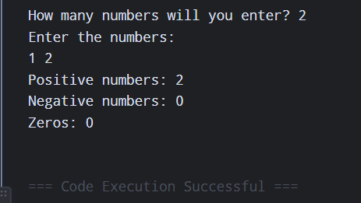

Q3. Compute the tax due based on a tax table given below: Program Input: Salary amount. Program Output: Returns the tax due for 0.0 <= salary <= 150,000.00; returns-1.0 if salary is outside the table range.

Ans.3
#include <stdio.h>

double calculateTax(double salaryAmount)
{
if (salaryAmount < 0.0 || salaryAmount > 150000.0)
return -1.0;

if (salaryAmount <= 14999.99)
return salaryAmount * 0.15;

if (salaryAmount <= 29999.99)
return 2250.00 + (salaryAmount - 15000.00) * 0.18;

if (salaryAmount <= 49999.99)
return 5400.00 + (salaryAmount - 30000.00) * 0.22;

if (salaryAmount <= 79999.99)
return 11000.00 + (salaryAmount - 50000.00) * 0.27;

return 21600.00 + (salaryAmount - 80000.00) * 0.33;
}

int main()
{
double salaryAmount;
double taxAmount;

printf("Enter salary amount: ");
scanf("%lf", &salaryAmount);

taxAmount = calculateTax(salaryAmount);

if (taxAmount < 0)
printf("Tax Due: -1.0 (Salary out of range)\n");
else
printf("Tax Due: %.2f\n", taxAmount);

return 0;
}
OUTPUT:

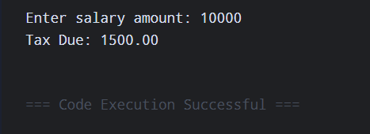

Q4. Write an interactive program (menu driven) in ‘C’ (using functions) to compute the area of a selected geometrical figure from a list of such figures (square, rectangle, and circle).

Ans.4
#include <stdio.h>

#define PI 3.14159

float squareArea(float side)
{
return side * side;
}

float rectangleArea(float length, float width)
{
return length * width;
}

float circleArea(float radius)
{
return PI * radius * radius;
}

int main()
{
int selectedShape;
float firstValue, secondValue;

printf("1. Square\n");
printf("2. Rectangle\n");
printf("3. Circle\n");
printf("Choose a shape: ");
scanf("%d", &selectedShape);

switch (selectedShape)
{
case 1:
printf("Enter side: ");
scanf("%f", &firstValue);
printf("Area = %.2f\n", squareArea(firstValue));
break;

case 2:
printf("Enter length and width: ");
scanf("%f %f", &firstValue, &secondValue);
printf("Area = %.2f\n",
rectangleArea(firstValue, secondValue));
break;

case 3:
printf("Enter radius: ");
scanf("%f", &firstValue);
printf("Area = %.2f\n", circleArea(firstValue));
break;

default:
printf("Invalid choice.\n");
}

return 0;
}

OUTPUT:

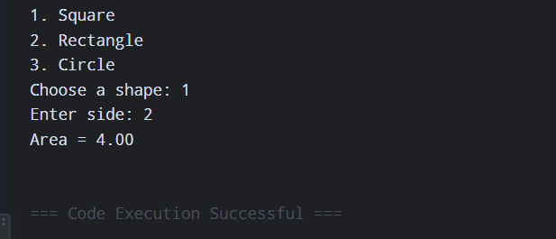

Q5. Write a program to display first n elements of Fibonacci series.

Ans.5 #include <stdio.h>

int main()
{
int terms;
int previous = 0;
int current = 1;

printf("Enter number of terms: ");
scanf("%d", &terms);

printf("Fibonacci Series: ");

for (int count = 0; count < terms; count++)
{
printf("%d ", previous);

int following = previous + current;
previous = current;
current = following;
}

printf("\n");

return 0;
}

OUTPUT:

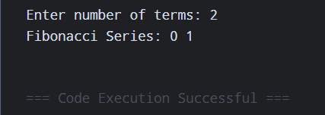

Q6. Write a program to print a table book from Table X to Table Y. X and Y are user inputs.

Ans.6 #include <stdio.h>

int main()
{
int firstTable;
int lastTable;

printf("Enter starting and ending table: ");
scanf("%d %d", &firstTable, &lastTable);

for (int tableNumber = firstTable;
tableNumber <= lastTable;
tableNumber++)
{
printf("\n--- Table of %d ---\n", tableNumber);

for (int multiplier = 1; multiplier <= 10; multiplier++)
{
printf("%d x %d = %d\n",
tableNumber,
multiplier,
tableNumber * multiplier);
}
}

return 0;
}
OUTPUT:

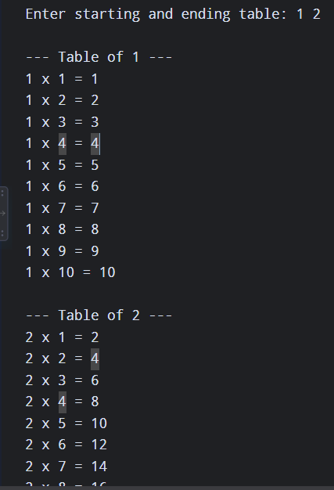

Q7. Write a program to compute factorial of a number using iterative approach.

Ans.7 #include <stdio.h>

int main()
{
int number;
unsigned long long factorial = 1;

printf("Enter a number: ");
scanf("%d", &number);

if (number < 0)
{
printf("Factorial is not defined for a negative number.\n");
return 0;
}

for (int value = 2; value <= number; value++)
factorial *= value;

printf("Factorial of %d = %llu\n", number, factorial);

return 0;
}

OUTPUT:

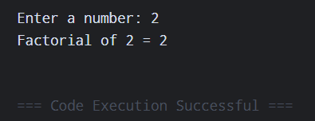

Q8. Write a program to swap two numbers using functions.

Ans.8 #include <stdio.h>

void exchangeValues(int *firstNumber, int *secondNumber)
{
int temporaryValue = *firstNumber;
*firstNumber = *secondNumber;
*secondNumber = temporaryValue;
}

int main()
{
int firstNumber;
int secondNumber;

printf("Enter two numbers: ");
scanf("%d %d", &firstNumber, &secondNumber);

exchangeValues(&firstNumber, &secondNumber);

printf("After swapping: first = %d, second = %d\n",
firstNumber, secondNumber);

return 0;
}

OUTPUT:

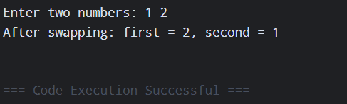

Q9. Write a function that returns the first integer between n_min and n_max entered as data to the calling function (main).

Ans.9 #include <stdio.h>

int readNumberInRange(int minimumValue, int maximumValue)
{
int enteredValue;

do
{
printf("Enter a number from %d to %d: ",
minimumValue, maximumValue);
scanf("%d", &enteredValue);

} while (enteredValue < minimumValue ||
enteredValue > maximumValue);

return enteredValue;
}

int main(void)
{
int minimumValue = 10;
int maximumValue = 50;

int acceptedValue =
readNumberInRange(minimumValue, maximumValue);

printf("Accepted value: %d\n", acceptedValue);

return 0;
}

OUTPUT:

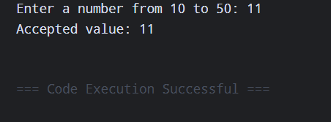

Q10. Write nests of loops that cause the following output to be displayed.

Ans.10 #include <stdio.h>

int main()
{
int row;
int value;

for (row = 0; row <= 5; row++)
{
for (value = 0; value <= row; value++)
printf("%d ", value);

printf("\n");
}

for (row = 4; row >= 0; row--)
{
for (value = 0; value <= row; value++)
printf("%d ", value);

printf("\n");
}

return 0;
}

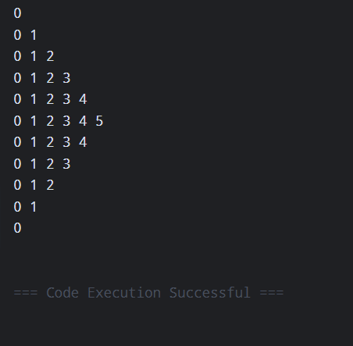OUTPUT:
Arrays and Pointers

Q1. Write a program to check whether a given number is present in an array or not (Linear search)

Ans.1 #include <stdio.h>

int main()
{
int numbers[100];
int size;
int target;
int foundPosition = -1;

printf("Enter number of elements: ");
scanf("%d", &size);

printf("Enter array elements: ");
for (int index = 0; index < size; index++)
scanf("%d", &numbers[index]);

printf("Enter number to search: ");
scanf("%d", &target);

for (int index = 0; index < size; index++)
{
if (numbers[index] == target)
{
foundPosition = index;
break;
}
}

if (foundPosition != -1)
printf("Element found at position %d\n", foundPosition + 1);
else
printf("Element not present in the array.\n");

return 0;
}

OUTPUT:

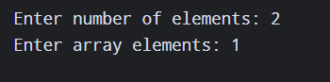

Q2.Write a program to get second maximum and second minimum elements in an array.

Ans.2 #include <stdio.h>
#include <limits.h>

int main()
{
int numbers[100];
int size;

int largest = INT_MIN;
int secondLargest = INT_MIN;
int smallest = INT_MAX;
int secondSmallest = INT_MAX;

printf("Enter number of elements: ");
scanf("%d", &size);

if (size < 2)
{
printf("At least two elements are required.\n");
return 0;
}

printf("Enter array elements: ");
for (int index = 0; index < size; index++)
scanf("%d", &numbers[index]);

for (int index = 0; index < size; index++)
{
int value = numbers[index];

if (value > largest)
{
secondLargest = largest;
largest = value;
}
else if (value > secondLargest && value != largest)
{
secondLargest = value;
}

if (value < smallest)
{
secondSmallest = smallest;
smallest = value;
}
else if (value < secondSmallest && value != smallest)
{
secondSmallest = value;
}
}

printf("Second maximum: %d\n", secondLargest);
printf("Second minimum: %d\n", secondSmallest);

return 0;
}

OUTPUT:
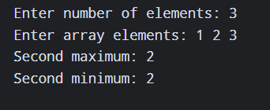

Q3. Write a program to perform insertion (any location), deletion (any location) and traversal in an array.

Ans.3 #include <stdio.h>

void insertAtPosition(int data[], int *size, int position, int value)
{
for (int index = *size; index >= position; index--)
data[index] = data[index - 1];

data[position - 1] = value;
(*size)++;
}

void deleteAtPosition(int data[], int *size, int position)
{
for (int index = position - 1; index < *size - 1; index++)
data[index] = data[index + 1];

(*size)--;
}

void showArray(const int data[], int size)
{
printf("Array: ");
for (int index = 0; index < size; index++)
printf("%d ", data[index]);
printf("\n");
}

int main()
{
int data[100];
int size;
int position;
int value;

printf("Enter number of elements: ");
scanf("%d", &size);

printf("Enter elements: ");
for (int index = 0; index < size; index++)
scanf("%d", &data[index]);

printf("Enter insertion position and value: ");
scanf("%d %d", &position, &value);
insertAtPosition(data, &size, position, value);

printf("Enter deletion position: ");
scanf("%d", &position);
deleteAtPosition(data, &size, position);

showArray(data, size);

return 0;
}

OUTPUT:
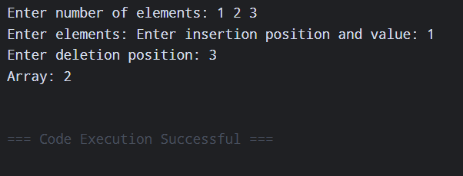

Q4. Write a menu driven program to perform addition, multiplication and subtraction of 2 arrays.

Ans.4 #include <stdio.h>

int main()
{
int first[50], second[50], result[50];
int size;
int choice;

printf("Enter size of both arrays: ");
scanf("%d", &size);

printf("Enter first array: ");
for (int index = 0; index < size; index++)
scanf("%d", &first[index]);

printf("Enter second array: ");
for (int index = 0; index < size; index++)
scanf("%d", &second[index]);

printf("\n1. Addition");
printf("\n2. Subtraction");
printf("\n3. Multiplication");
printf("\nChoose an operation: ");
scanf("%d", &choice);

if (choice < 1 || choice > 3)
{
printf("Invalid choice.\n");
return 0;
}

for (int index = 0; index < size; index++)
{
if (choice == 1)
result[index] = first[index] + second[index];
else if (choice == 2)
result[index] = first[index] - second[index];
else
result[index] = first[index] * second[index];
}

printf("Result: ");
for (int index = 0; index < size; index++)
printf("%d ", result[index]);

printf("\n");
return 0;
}

OUTPUT:
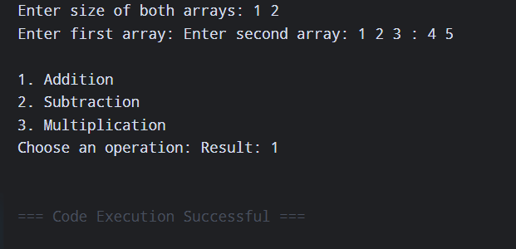

Q5. Write a program to perform sorting while merging (Merge two sorted arrays into one sorted array).

Ans.5 #include <stdio.h>

int main()
{
int first[50], second[50], merged[100];
int firstSize, secondSize;
int left = 0, right = 0, mergedSize = 0;

printf("Enter size of first sorted array: ");
scanf("%d", &firstSize);

printf("Enter first sorted array: ");
for (int index = 0; index < firstSize; index++)
scanf("%d", &first[index]);

printf("Enter size of second sorted array: ");
scanf("%d", &secondSize);

printf("Enter second sorted array: ");
for (int index = 0; index < secondSize; index++)
scanf("%d", &second[index]);

while (left < firstSize && right < secondSize)
{
if (first[left] <= second[right])
merged[mergedSize++] = first[left++];
else
merged[mergedSize++] = second[right++];
}

while (left < firstSize)
merged[mergedSize++] = first[left++];

while (right < secondSize)
merged[mergedSize++] = second[right++];

printf("Merged sorted array: ");
for (int index = 0; index < mergedSize; index++)
printf("%d ", merged[index]);

printf("\n");
return 0;
}

OUTPUT:
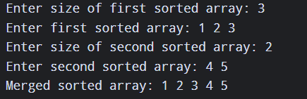

Q6.1 #include <stdio.h>
int linearSearch(int *arr, int *n, int *key) {
for (int i = 0; i < *n; i++) {
if (*(arr + i) == *key) return i + 1;
}
return -1;
}
int main() {
int arr[100], n, key;
printf("Enter n: ");
scanf("%d", &n);
printf("Enter elements: ");
for (int i = 0; i < n; i++) scanf("%d", &arr[i]);
printf("Enter number to search: ");
scanf("%d", &key);
int pos = linearSearch(arr, &n, &key);
if (pos != -1) printf("Found at position: %d\n", pos);
else printf("Not found\n");
return 0;
}

OUTPUT:

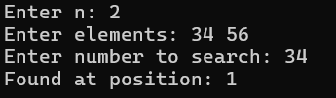

Q6.2 #include <stdio.h>
#include <limits.h>
void findSecondExtremes(int *arr, int *n, int *sec_max, int *sec_min) {
int max = INT_MIN, min = INT_MAX;
*sec_max = INT_MIN;
*sec_min = INT_MAX;
for (int i = 0; i < *n; i++) {
if (*(arr + i) > max) {
*sec_max = max;
max = *(arr + i);
} else if (*(arr + i) > *sec_max && *(arr + i) != max) {
*sec_max = *(arr + i);
}
if (*(arr + i) < min) {
*sec_min = min;
min = *(arr + i);
} else if (*(arr + i) < *sec_min && *(arr + i) != min) {
*sec_min = *(arr + i);
} } }
int main() {
int arr[100], n, sec_max, sec_min;
printf("Enter n: ");
scanf("%d", &n);
printf("Enter elements: ");
for (int i = 0; i < n; i++) scanf("%d", &arr[i]);
findSecondExtremes(arr, &n, &sec_max, &sec_min);
printf("Second Max: %d\n", sec_max);
printf("Second Min: %d\n", sec_min);
return 0;
}

OUTPUT:

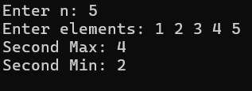

Q6.3 #include <stdio.h>
void insertElement(int *arr, int *n, int *pos, int *val) {
for (int i = *n; i >= *pos; i--) *(arr + i) = *(arr + i - 1);
*(arr + *pos - 1) = *val;
(*n)++;
}
void deleteElement(int *arr, int *n, int *pos) {
for (int i = *pos - 1; i < *n - 1; i++) *(arr + i) = *(arr + i + 1);
(*n)--;
}
void traverseArray(int *arr, int *n) {
printf("Array: ");
for (int i = 0; i < *n; i++) printf("%d ", *(arr + i));
printf("\n");
}
int main() {
int arr[100], n, pos, val;
printf("Enter n: ");
scanf("%d", &n);
printf("Enter elements: ");
for (int i = 0; i < n; i++) scanf("%d", &arr[i]);
printf("Enter insert pos & val: ");
scanf("%d %d", &pos, &val);
insertElement(arr, &n, &pos, &val);
printf("Enter delete pos: ");
scanf("%d", &pos);
deleteElement(arr, &n, &pos);
traverseArray(arr, &n);
return 0;
}

OUTPUT:

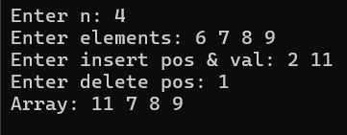

Q7. You are given an integer array nums.
Your task is to sort the array based on two rules: Elements with lower frequency come first. If two elements have the same frequency, the larger value comes first.
Ans.7 #include <stdio.h>

int main()
{
int nums[100];
int frequency[100];
int size;

printf("Enter number of elements: ");
scanf("%d", &size);

printf("Enter elements: ");
for (int index = 0; index < size; index++)
scanf("%d", &nums[index]);

for (int index = 0; index < size; index++)
{
frequency[index] = 0;

for (int scan = 0; scan < size; scan++)
{
if (nums[index] == nums[scan])
frequency[index]++;
}
}

for (int start = 0; start < size - 1; start++)
{
for (int next = start + 1; next < size; next++)
{
int shouldMove =
(frequency[start] > frequency[next]) ||
(frequency[start] == frequency[next] &&
nums[start] < nums[next]);

if (shouldMove)
{
int tempNumber = nums[start];
nums[start] = nums[next];
nums[next] = tempNumber;

int tempFrequency = frequency[start];
frequency[start] = frequency[next];
frequency[next] = tempFrequency;
}
}
}

printf("Sorted array: ");
for (int index = 0; index < size; index++)
printf("%d ", nums[index]);

printf("\n");
return 0;
}

OUTPUT:

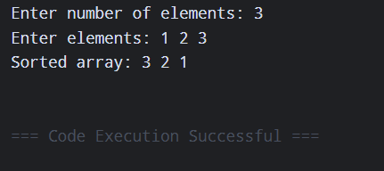

Q8. You are given an array students, where each element is of the form:
[name, marks, age]
Sort the students according to the following rules: Higher marks should come first. If marks are equal, younger age comes first. If both marks and age are equal, sort by name in alphabetical order. Return the sorted list.

Ans.8 #include <stdio.h>
#include <string.h>
struct Student {
char name[50];
int marks;
int age;
};
int main() {
int n, i, j;
struct Student s[100], temp;
printf("Enter number of students: ");
scanf("%d", &n);

for (i = 0; i < n; i++) {
printf("Enter name, marks, age: ");
scanf("%s %d %d", s[i].name, &s[i].marks, &s[i].age);
}

for (i = 0; i < n - 1; i++) {
for (j = i + 1; j < n; j++) {
int swap = 0;
if (s[i].marks < s[j].marks) {
swap = 1;
} else if (s[i].marks == s[j].marks) {
if (s[i].age > s[j].age) {
swap = 1;
} else if (s[i].age == s[j].age) {
if (strcmp(s[i].name, s[j].name) > 0) {
swap = 1;
}
}
}

if (swap) {
temp = s[i];
s[i] = s[j];
s[j] = temp;
}
}
}

printf("Sorted Students:\n");
for (i = 0; i < n; i++) {
printf("%s %d %d\n", s[i].name, s[i].marks, s[i].age);
}
return 0;
}

OUTPUT:
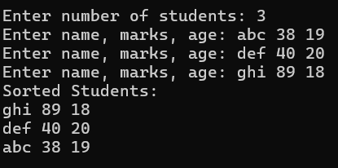
String Processing Operations

Q1. Write a program to implement strlen() function

Ans.1 #include <stdio.h>
int my_strlen(const char *str) {
int len = 0;
while (str[len] != '\0') {
len++;
}
return len;
}
int main(void) {
char str[] = "Hello, World!";
printf("%d\n", my_strlen(str));
return 0;
}

OUTPUT:

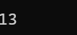

Q2. Write a program to implement strcpy() function

Ans.2 #include <stdio.h>
char *my_strcpy(char *dest, const char *src) {
int i = 0;
while (src[i] != '\0') {
dest[i] = src[i];
i++;
}
dest[i] = '\0';
return dest;
}
int main(void) {
char src[] = "Hello";
char dest[20];
my_strcpy(dest, src);
printf("%s\n", dest);
return 0;
}

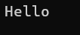
OUTPUT:

Q3. Write a program to implement strcat() function.

Ans 3. #include <stdio.h>
char *my_strcat(char *dest, const char *src) {
int i = 0;
while (dest[i] != '\0') {
i++;
}
int j = 0;
while (src[j] != '\0') {
dest[i] = src[j];
i++;
j++;
}
dest[i] = '\0';
return dest;
}
int main(void) {
char dest[50] = "Hello, ";
char src[] = "World!";
my_strcat(dest, src);
printf("%s\n", dest);

return 0;
}

OUTPUT:

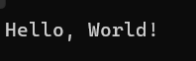

Q4. Write a program to implement strcmp() function.

Ans 4. #include <stdio.h>
int my_strcmp(const char *s1, const char *s2) {
int i = 0;
while (s1[i] != '\0' && s1[i] == s2[i]) {
i++;
}
return (unsigned char)s1[i] - (unsigned char)s2[i];
}
int main(void) {
char str1[] = "apple";
char str2[] = "apple";
char str3[] = "banana";
printf("%d\n", my_strcmp(str1, str2));
printf("%d\n", my_strcmp(str1, str3));
printf("%d\n", my_strcmp(str3, str1)); return 0;
}

OUTPUT:

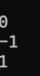

Q5. WAP to demonstrate limitations of Two-Dimensional Array of Characters.

Ans 5. #include <stdio.h>

int main(void) {
char names[3][20] = {
"AI",
"Programming",
"C"
};
printf("Total memory allocated: %zu bytes\n", sizeof(names));
for (int i = 0; i < 3; i++) {
printf("Row %d: \"%s\" (Occupies 20 bytes)\n", i, names[i]);
}
return 0;
}

OUTPUT:
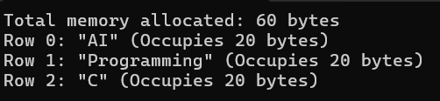

Q6. WAP to demonstrate an array of Pointers to Strings.

Ans 6. #include <stdio.h>
int main(void) {
const char *names[3] = {
"AI",
"Programming",
"C"
};
for (int i = 0; i < 3; i++) {
printf("Index %d: %s\n", i, names[i]);
}
return 0;
}

OUTPUT:

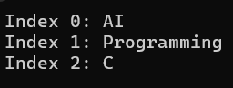

Linked List

Q1. Write a program to implement single Link List (with function insertion at first node,
insertion at last node, insertion and deletion at middle node and traversing of link list
after each node insertion).

Ans 1. #include <stdio.h>
#include <stdlib.h>
struct Node {
int data;
struct Node* next;
};
void display(struct Node* head) {
for (; head; head = head->next) printf("%d -> ", head->data);
printf("NULL\n");
}
void insert(struct Node** head, int val, int pos) {
struct Node* n = malloc(sizeof(struct Node));
n->data = val;
while (*head && --pos > 0) head = &(*head)->next;
n->next = *head;
*head = n;
}
void delete(struct Node** head, int pos) {
while (*head && --pos > 0) head = &(*head)->next;
if (*head) {
struct Node* temp = *head;
*head = (*head)->next;
free(temp);
}
}
int main() {
struct Node* head = NULL;
int choice, val, pos;
while (1) {
printf("\n1.Insert Begin 2.Insert End 3.Insert Mid 4.Delete Mid 5.Exit: ");
if (scanf("%d", &choice) != 1 || choice == 5) break;
switch (choice) {
case 1:
scanf("%d", &val);
insert(&head, val, 1);
Break;
case 2:
scanf("%d", &val);
insert(&head, val, 10000);
break;
case 3:
scanf("%d %d", &val, &pos);
insert(&head, val, pos);
break;
case 4:
scanf("%d", &pos);
delete(&head, pos);
break;
default:
continue;
}
display(head);
}
return 0;
}

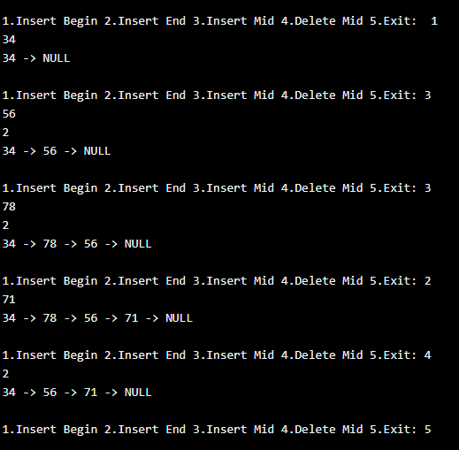
OUTPUT:

Q2. Write a program to implement Doubly Link List (with function insertion at first node, insertion at last node, deletion at first node, deletion at last node, insertion and deletion at middle node and traversing of link list).

Ans 2.
#include <stdio.h>
#include <stdlib.h>
struct node {
int data;
struct node *prev, *next;
};
struct node *head = NULL;
void display() {
struct node *t = head;
while (t != NULL) {
printf("%d -> ", t->data);
t = t->next;
}
printf("NULL\n");
}
void insertBegin() {
struct node *n = malloc(sizeof(struct node));
scanf("%d", &n->data);
n->prev = NULL;
n->next = head;
if (head) head->prev = n;
head = n;
display();
}
void insertEnd() {
struct node *n = malloc(sizeof(struct node)), *t = head;
scanf("%d", &n->data);
n->next = NULL;
if (!head) {
n->prev = NULL;
head = n;
} else {
while (t->next) t = t->next;
t->next = n;
n->prev = t;
}
display();
}
void insertMid() {
struct node *n, *t = head;
int p, i;
scanf("%d%d", &n->data, &p);
if (p <= 1) {
n->prev = NULL;
n->next = head;
if (head) head->prev = n;
head = n;
display();
return;
}
for (i = 1; i < p - 1 && t; i++) t = t->next;
if (!t) return;
n->next = t->next;
n->prev = t;
if (t->next) t->next->prev = n;
t->next = n;
display();
}
void deleteMid() {
struct node *t = head;
int p, i;
scanf("%d", &p);
for (i = 1; i < p && t; i++) t = t->next;
if (!t) return;
if (t->prev) t->prev->next = t->next;
else head = t->next;
if (t->next) t->next->prev = t->prev;
free(t);
display();
}
int main() {
int ch;
do {
printf("\n1.Insert Begin 2.Insert End 3.Insert Mid 4.Delete Mid 5.Exit: ");
scanf("%d", &ch);
switch (ch) {
case 1: insertBegin(); break;
case 2: insertEnd(); break;
case 3: insertMid(); break;
case 4: deleteMid(); break;
case 5: break;
default: printf("Invalid choice\n");
}
} while (ch != 5);
return 0;
}

OUTPUT:

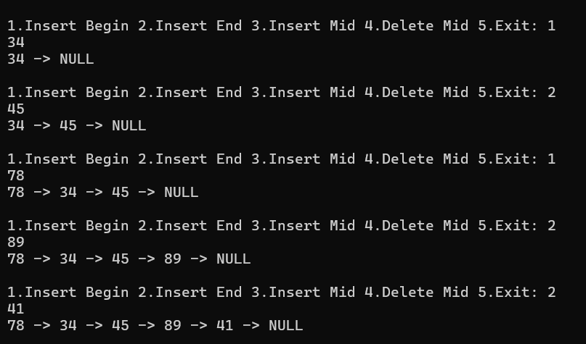

Q3. Write a program to implement Circular Doubly Link List (with function insertion at first node, insertion at last node, deletion at first node, deletion at last node, insertion and deletion at middle node and traversing of link list).

Ans 3.
#include <stdio.h>
#include <stdlib.h>
struct node {
int data;
struct node *prev, *next;
};
struct node *head = NULL;
void display() {
struct node *t = head;
if (!head) {
printf("List is empty\n");
return;
}
do {
printf("%d -> ", t->data);
t = t->next;
} while (t != head);
printf("(HEAD)\n");
}
void insertBegin() {
struct node *n = malloc(sizeof(struct node));
scanf("%d", &n->data);
if (!head) {
n->next = n->prev = n;
head = n;
} else {
struct node *last = head->prev;
n->next = head;
n->prev = last;
last->next = n;
head->prev = n;
head = n;
}
display();
}
void insertEnd() {
struct node *n = malloc(sizeof(struct node));
scanf("%d", &n->data);
if (!head) {
n->next = n->prev = n;
head = n;
} else {
struct node *last = head->prev;
n->next = head;
n->prev = last;
last->next = n;
head->prev = n;
}
display();
}
void deleteBegin() {
if (!head) {
printf("List is empty\n");
return;
}
struct node *t = head;
if (head->next == head)
head = NULL;
else {
struct node *last = head->prev;
head = head->next;
head->prev = last;
last->next = head;
}
free(t);
display();
}
void deleteEnd() {
if (!head) {
printf("List is empty\n");
return;
}
struct node *t = head->prev;
if (t == head)
head = NULL;
else {
head->prev = t->prev;
t->prev->next = head;
}
free(t);
display();
}
void insertMid() {
struct node *t = head, *n;
int p, i;
if (!head) {
printf("List is empty\n");
return;
}
n = malloc(sizeof(struct node));
scanf("%d%d", &n->data, &p);
if (p <= 1) {
free(n);
insertBegin();
return;
}
for (i = 1; i < p - 1 && t->next != head; i++)
t = t->next;
n->next = t->next;
n->prev = t;
t->next->prev = n;
t->next = n;
display();
}
void deleteMid() {
struct node *t = head;
int p, i;
if (!head) {
printf("List is empty\n");
return;
}
scanf("%d", &p);
if (p <= 1) {
deleteBegin();
return;
}
for (i = 1; i < p && t->next != head; i++)
t = t->next;
if (i != p) {
printf("Invalid position\n");
return;
}
t->prev->next = t->next;
t->next->prev = t->prev;
free(t);

display();
}
int main() {
int ch;
do {
printf("\n1.Insert Begin 2.Insert End 3.Delete Begin 4.Delete End 5.Insert Mid 6.Delete Mid 7.Traverse 8.Exit: ");
scanf("%d", &ch);
switch (ch) {
case 1: insertBegin(); break;
case 2: insertEnd(); break;
case 3: deleteBegin(); break;
case 4: deleteEnd(); break;
case 5: insertMid(); break;
case 6: deleteMid(); break;
case 7: display(); break;
case 8: break;
default: printf("Invalid choice\n");
}
} while (ch != 8);
return 0;
}

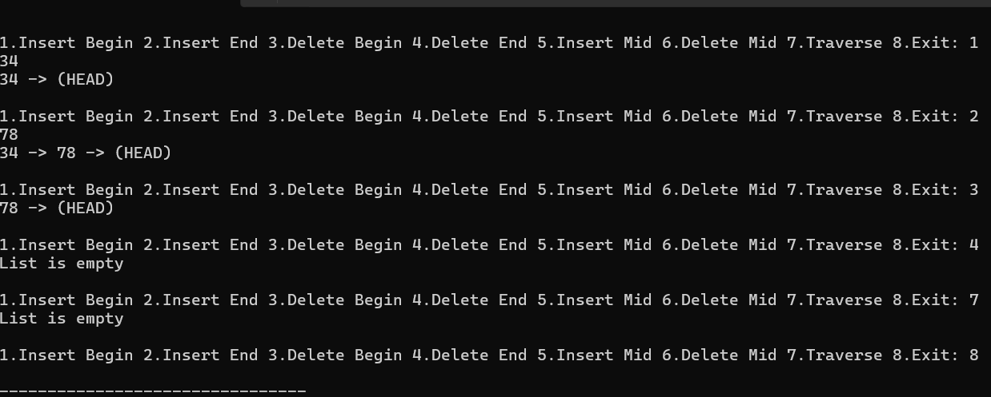
OUTPUT:

Stack and its Applications

Q1. Write a menu driven program with 4 options (Push, Pop, Display, and Exit) to demonstrate the working of stacks using arrays.

Ans 1.
#include <stdio.h>
#define MAX 5
int stack[MAX], top = -1;
void push() {
int x;
if (top == MAX - 1) {
printf("Stack Overflow\n");
return;
}
scanf("%d", &x);
stack[++top] = x;
printf("Pushed: %d\n", x);
}
void pop() {
if (top == -1) {
printf("Stack Underflow\n");
return;
}
printf("Popped: %d\n", stack[top--]);
}
void display() {
int i;
if (top == -1) {
printf("Stack is empty\n");
return;
}
for (i = top; i >= 0; i--)
printf("%d\n", stack[i]);
}
int main() {
int ch;
do {
printf("\n1.Push 2.Pop 3.Display 4.Exit: ");
scanf("%d", &ch);
switch (ch) {
case 1: push(); break;
case 2: pop(); break;
case 3: display(); break;
case 4: break;
default: printf("Invalid choice\n");
}
} while (ch != 4);
return 0;
}

OUTPUT:

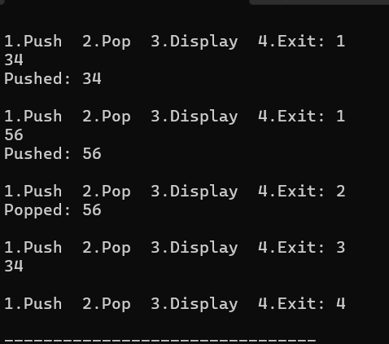

Q2. Write a menu driven program with 4 options (Push, Pop, Display, and Exit) to demonstrate the working of stacks using linked-list.

Ans 2.
#include <stdio.h>
#include <stdlib.h>
struct node {
int data;
struct node *next;
};
struct node *top = NULL;
void push() {
struct node *n = malloc(sizeof(struct node));
scanf("%d", &n->data);
n->next = top;
top = n;
printf("Pushed: %d\n", top->data);
}
void pop() {
struct node *t;
if (top == NULL) {
printf("Stack Underflow\n");
return;
}
t = top;
printf("Popped: %d\n", t->data);
top = top->next;
free(t);
}
void display() {
struct node *t = top;
if (top == NULL) {
printf("Stack is empty\n");
return;
}
while (t != NULL) {
printf("%d\n", t->data);
t = t->next;
}
}
int main() {
int ch;
do {
printf("\n1.Push 2.Pop 3.Display 4.Exit: ");
scanf("%d", &ch);

switch (ch) {
case 1: push(); break;
case 2: pop(); break;
case 3: display(); break;
case 4: break;
default: printf("Invalid choice\n");
}
} while (ch != 4);
return 0;
}

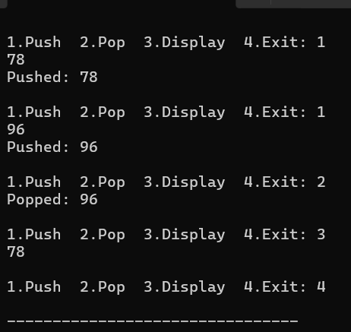
OUTPUT:

Q3. Write a program to convert infix expression into postfix expression using stack.

Ans 3.
#include <stdio.h>
#include <ctype.h>
char stack[100];
int top = -1;
void push(char x) {
stack[++top] = x;
}
char pop() {
return stack[top--];
}
int priority(char x) {
if (x == '^') return 3;
if (x == '*' || x == '/') return 2;
if (x == '+' || x == '-') return 1;
return 0;
}
int main() {
char infix[100], postfix[100];
int i, j = 0;
printf("Enter infix: ");
scanf("%s", infix);
for (i = 0; infix[i] != '\0'; i++) {
char x = infix[i];
if (isalnum(x))
postfix[j++] = x;
else if (x == '(')
push(x);
else if (x == ')') {
while (top != -1 && stack[top] != '(')
postfix[j++] = pop();
if (top != -1) pop();
}
else {
while (top != -1 && stack[top] != '(' &&
(priority(stack[top]) > priority(x) ||
(priority(stack[top]) == priority(x) && x != '^')))
postfix[j++] = pop();

push(x);
}
}
while (top != -1)
postfix[j++] = pop();
postfix[j] = '\0';
printf("Postfix: %s\n", postfix);
return 0;
}

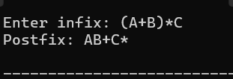
OUTPUT:

Q4. Write a program to convert infix expression into prefix expression using stack.

Ans 4.
#include <stdio.h>
#include <string.h>
#include <ctype.h>
char stack[100];
int top = -1;
void push(char x) {
stack[++top] = x;
}
char pop() {
return stack[top--];
}
int priority(char x) {
if (x == '^') return 3;
if (x == '*' || x == '/') return 2;
if (x == '+' || x == '-') return 1;
return 0;
}
int main() {
char infix[100], prefix[100], temp;
int i, j = 0, k;
printf("Enter infix: ");
scanf("%s", infix);
strrev(infix);
for (i = 0; infix[i] != '\0'; i++) {
if (infix[i] == '(')
infix[i] = ')';
else if (infix[i] == ')')
infix[i] = '(';
}
for (i = 0; infix[i] != '\0'; i++) {
char x = infix[i];
if (isalnum(x))
prefix[j++] = x;
else if (x == '(')
push(x);
else if (x == ')') {
while (top != -1 && stack[top] != '(')
prefix[j++] = pop();
if (top != -1) pop();
}
else {
while (top != -1 && stack[top] != '(' &&
(priority(stack[top]) > priority(x) ||
(priority(stack[top]) == priority(x) && x == '^')))
prefix[j++] = pop();
push(x);
}
}
while (top != -1)
prefix[j++] = pop();

prefix[j] = '\0';
for (i = 0, k = j - 1; i < k; i++, k--) {
temp = prefix[i];
prefix[i] = prefix[k];
prefix[k] = temp;
}
printf("Prefix: %s\n", prefix);
return 0;
}

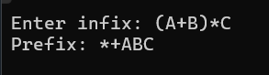
OUTPUT:

Q5. Write a program to evaluate a postfix expression using stack.

Ans 5.
#include <stdio.h>
#include <ctype.h>
int stack[100], top = -1;
void push(int x) {
stack[++top] = x;
}
int pop() {
return stack[top--];
}
int main() {
char exp[100];
int i, a, b, result;
printf("Enter postfix: ");
scanf("%s", exp);
for (i = 0; exp[i] != '\0'; i++) {
char x = exp[i];
if (isdigit(x))
push(x - '0');
else {
b = pop();
a = pop();
switch (x) {
case '+': result = a + b; break;
case '-': result = a - b; break;
case '*': result = a * b; break;
case '/': result = a / b; break;
case '^': {
result = 1;
while (b--) result *= a;
break;
}
}
push(result);
}
}
printf("Result: %d\n", pop());
return 0;
}

OUTPUT:

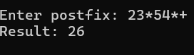

Queues

Q1. Write a menu driven program with 4 options (Insert, Delete, Display, and Exit) to demonstrate the working of Queues using arrays.

Ans 1.
#include <stdio.h>
#define MAX 5
int queue[MAX], front = -1, rear = -1;
void insert() {
int x;
if (rear == MAX - 1) {
printf("Queue Overflow\n");
return;
}
scanf("%d", &x);
if (front == -1) front = 0;
queue[++rear] = x;
printf("Inserted: %d\n", x);
}
void delete() {
if (front == -1 || front > rear) {
printf("Queue Underflow\n");
return;
}
printf("Deleted: %d\n", queue[front]);
front++;
if (front > rear)
front = rear = -1;
}
void display() {
int i;
if (front == -1) {
printf("Queue is empty\n");
return;
}
for (i = front; i <= rear; i++)
printf("%d ", queue[i]);
printf("\n");
}

int main() {
int ch;
do {
printf("\n1.Insert 2.Delete 3.Display 4.Exit: ");
scanf("%d", &ch);
switch (ch) {
case 1: insert(); break;
case 2: delete(); break;
case 3: display(); break;
case 4: break;
default: printf("Invalid choice\n");
}
} while (ch != 4);
return 0;
}

OUTPUT:
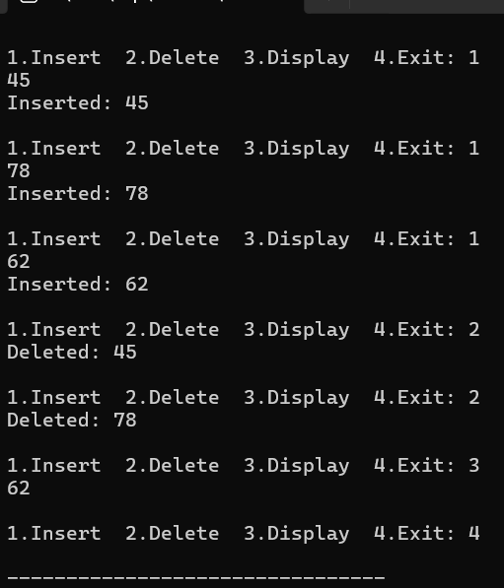

Q2. Write a menu driven program with 4 options (Insert, Delete, Display, and Exit) to demonstrate the working of Circular Queues (arrays.)

Ans 2.
#include <stdio.h>
#define MAX 5
int queue[MAX], front = -1, rear = -1;
void insert() {
int x;
if ((rear + 1) % MAX == front) {
printf("Queue Overflow\n");
return;
}
scanf("%d", &x);
if (front == -1)
front = rear = 0;
else
rear = (rear + 1) % MAX;
queue[rear] = x;
printf("Inserted: %d\n", x);
}
void delete() {
if (front == -1) {
printf("Queue Underflow\n");
return;
}
printf("Deleted: %d\n", queue[front]);
if (front == rear)
front = rear = -1;
else
front = (front + 1) % MAX;
}
void display() {
int i;
if (front == -1) {
printf("Queue is empty\n");
return;
}
i = front;
while (1) {
printf("%d ", queue[i]);
if (i == rear) break;
i = (i + 1) % MAX;
}
printf("\n");
}
int main() {
int ch;
do {
printf("\n1.Insert 2.Delete 3.Display 4.Exit: ");
scanf("%d", &ch);
switch (ch) {
case 1: insert(); break;
case 2: delete(); break;
case 3: display(); break;
case 4: break;
default: printf("Invalid choice\n");
}
} while (ch != 4);
return 0;
}

OUTPUT:

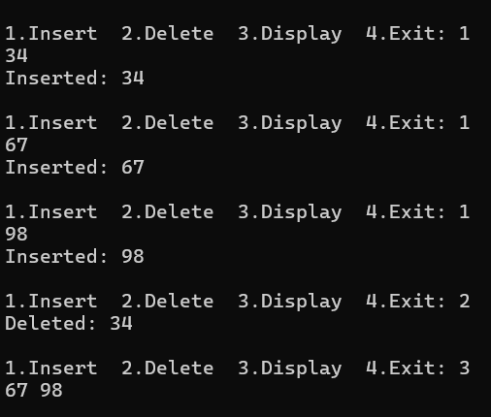

Sorting Algorithms

Q1. Write a program to implement bubble sort for sorting n elements in an array.

Ans 1.
#include <stdio.h>
int main() {
int a[100], n, i, j, temp;
printf("Enter n: ");
scanf("%d", &n);
printf("Enter elements: ");
for (i = 0; i < n; i++)
scanf("%d", &a[i]);
for (i = 0; i < n - 1; i++) {
for (j = 0; j < n - i - 1; j++) {
if (a[j] > a[j + 1]) {
temp = a[j];
a[j] = a[j + 1];
a[j + 1] = temp;
}
}
}
printf("Sorted array: ");
for (i = 0; i < n; i++)
printf("%d ", a[i]);
return 0;
}

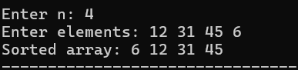
OUTPUT:

Q2. Write a program to implement Selection sort for sorting n elements in an array.

Ans 2.
#include <stdio.h>
int main() {
int a[100], n, i, j, min, temp;
printf("Enter n: ");
scanf("%d", &n);
printf("Enter elements: ");
for (i = 0; i < n; i++)
scanf("%d", &a[i]);
for (i = 0; i < n - 1; i++) {
min = i;
for (j = i + 1; j < n; j++) {
if (a[j] < a[min])
min = j;
}
temp = a[i];
a[i] = a[min];
a[min] = temp;
}
printf("Sorted array: ");
for (i = 0; i < n; i++)
printf("%d ", a[i]);
return 0;
}

OUTPUT:
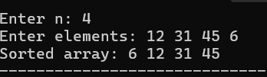

Q3. Write a program to implement Insertion sort for sorting n elements in an array.

Ans 3.
#include <stdio.h>

int main() {
int a[100], n, i, j, key;
printf("Enter n: ");
scanf("%d", &n);
printf("Enter elements: ");
for (i = 0; i < n; i++)
scanf("%d", &a[i]);
for (i = 1; i < n; i++) {
key = a[i];
j = i - 1;
while (j >= 0 && a[j] > key) {
a[j + 1] = a[j];
j--;
}
a[j + 1] = key;
}
printf("Sorted array: ");
for (i = 0; i < n; i++)
printf("%d ", a[i]);
return 0;
}

OUTPUT:

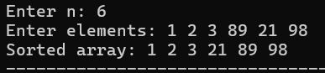

Q4. Write a program to implement Shell sort for sorting n elements in an array.

Ans 4.
#include <stdio.h>
int main() {
int a[100], n, i, j, gap, temp;
printf("Enter n: ");
scanf("%d", &n);
printf("Enter elements: ");
for (i = 0; i < n; i++)
scanf("%d", &a[i]);
for (gap = n / 2; gap > 0; gap /= 2) {
for (i = gap; i < n; i++) {
temp = a[i];
for (j = i; j >= gap && a[j - gap] > temp; j -= gap)
a[j] = a[j - gap];
a[j] = temp;
}
}
printf("Sorted array: ");
for (i = 0; i < n; i++)
printf("%d ", a[i]);

return 0;
}

OUTPUT:

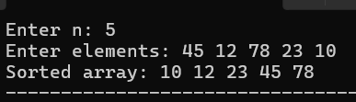

Q5. Write a program to implement Radix sort for sorting n elements in an array.

Ans 5.
#include <stdio.h>

int getMax(int a[], int n) {
int max = a[0], i;
for (i = 1; i < n; i++) {
if (a[i] > max)
max = a[i];
}
return max;
}
void countSort(int a[], int n, int exp) {
int output[100], count[10] = {0};
int i, digit;
for (i = 0; i < n; i++) {
digit = (a[i] / exp) % 10;
count[digit]++;
}
for (i = 1; i < 10; i++)
count[i] += count[i - 1];
for (i = n - 1; i >= 0; i--) {
digit = (a[i] / exp) % 10;
output[--count[digit]] = a[i];
}
for (i = 0; i < n; i++)
a[i] = output[i];
}
int main() {
int a[100], n, i, max, exp;
printf("Enter n: ");
scanf("%d", &n);
printf("Enter elements: ");
for (i = 0; i < n; i++)
scanf("%d", &a[i]);

max = getMax(a, n);
for (exp = 1; max / exp > 0; exp *= 10)
countSort(a, n, exp);
printf("Sorted array: ");
for (i = 0; i < n; i++)
printf("%d ", a[i]);
return 0;
}

OUTPUT:

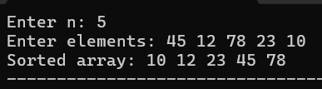

Q6. Write a program to implement Merge sort.

Ans 6.
#include <stdio.h>
void merge(int a[], int l, int m, int r) {
int b[100], i = l, j = m + 1, k = 0;
while (i <= m && j <= r) {
if (a[i] < a[j])
b[k++] = a[i++];
else
b[k++] = a[j++];
}
while (i <= m)
b[k++] = a[i++];
while (j <= r)
b[k++] = a[j++];
for (i = l, k = 0; i <= r; i++, k++)
a[i] = b[k];
}
void mergeSort(int a[], int l, int r) {
int m;
if (l < r) {
m = (l + r) / 2;
mergeSort(a, l, m);
mergeSort(a, m + 1, r);
merge(a, l, m, r);
}
}
int main() {
int a[100], n, i;
printf("Enter n: ");
scanf("%d", &n);
printf("Enter elements: ");
for (i = 0; i < n; i++)
scanf("%d", &a[i]);
mergeSort(a, 0, n - 1);
printf("Sorted array: ");
for (i = 0; i < n; i++)
printf("%d ", a[i]);
return 0;
}

OUTPUT:

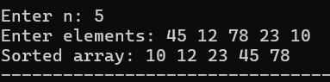

Q7. Write a program to implement Quick sort

Ans 7.
#include <stdio.h>
void quickSort(int a[], int low, int high) {
int i, j, pivot, temp;
if (low < high) {
pivot = a[high];
i = low - 1;
for (j = low; j < high; j++) {
if (a[j] < pivot) {
i++;
temp = a[i];
a[i] = a[j];
a[j] = temp;
}
}
temp = a[i + 1];
a[i + 1] = a[high];
a[high] = temp;
quickSort(a, low, i);
quickSort(a, i + 2, high);
}
}
int main() {
int a[100], n, i;
printf("Enter n: ");
scanf("%d", &n);
printf("Enter elements: ");
for (i = 0; i < n; i++)
scanf("%d", &a[i]);
quickSort(a, 0, n - 1);
printf("Sorted array: ");
for (i = 0; i < n; i++)
printf("%d ", a[i]);
return 0;
}

OUTPUT:
